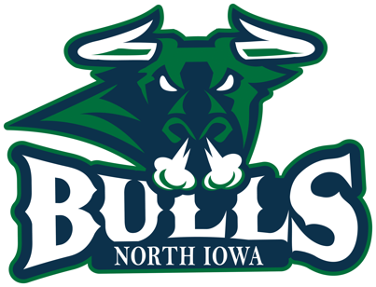

Please return completed form to address or email listed below. Requests will be considered and processed within 30 days. For more information, please contact our office.

Donation Request Form
Organization or Event:_________________________________________________________
Contact Name:________________________________________________________________
Contact Phone:_____________________ Email:_____________________________________
Date of Event:_________________________
Purpose of Event:______________________________________________________________
Date Donation Needed By:_______________________________________________________
Amount of Donation Requested:__________________________________________________
Item(s) Requested:______________________________________________________________

100 S. Federal Avenue, Suite 118 Mason City, Iowa 50401

Office Phone: 641-423-4625 Email: kcorsello@northiowabulls.com
Chief Operating Officer: Kathee Corsello

